Day 4 and Day 5 Hacker Rank
Python has built-in string validation methods for basic data. It can check if a string is composed of alphabetical characters, alphanumeric characters, digits, etc.
str.isalnum()
This method checks if all the characters of a string are alphanumeric (a-z, A-Z and 0-9).
>>> print 'ab123'.isalnum()
True
>>> print 'ab123#'.isalnum()
False

str.isalpha()
This method checks if all the characters of a string are alphabetical (a-z and A-Z).
>>> print 'abcD'.isalpha()
True
>>> print 'abcd1'.isalpha()
False

str.isdigit()
This method checks if all the characters of a string are digits (0-9).
>>> print '1234'.isdigit()
True
>>> print '123edsd'.isdigit()
False

str.islower()
This method checks if all the characters of a string are lowercase characters (a-z).
>>> print 'abcd123#'.islower()
True
>>> print 'Abcd123#'.islower()
False

str.isupper()
This method checks if all the characters of a string are uppercase characters (A-Z).
>>> print 'ABCD123#'.isupper()
True
>>> print 'Abcd123#'.isupper()
False

Task 1
You are given a string s.
Your task is to find out if the string s contains: alphanumeric characters, alphabetical characters, digits, lowercase and uppercase characters.
Input Format
A single line containing a string .
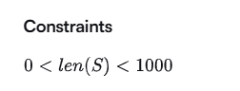

Output Format
In the first line, print True if has any alphanumeric characters. Otherwise, print False.
In the second line, print True if has any alphabetical characters. Otherwise, print False.
In the third line, print True if has any digits. Otherwise, print False.
In the fourth line, print True if has any lowercase characters. Otherwise, print False.
In the fifth line, print True if has any uppercase characters. Otherwise, print False.
Sample Input
qA2
Sample Output
True
True
True
True
True
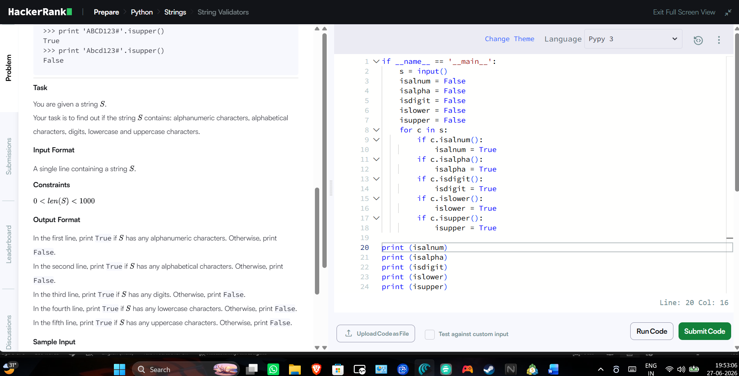
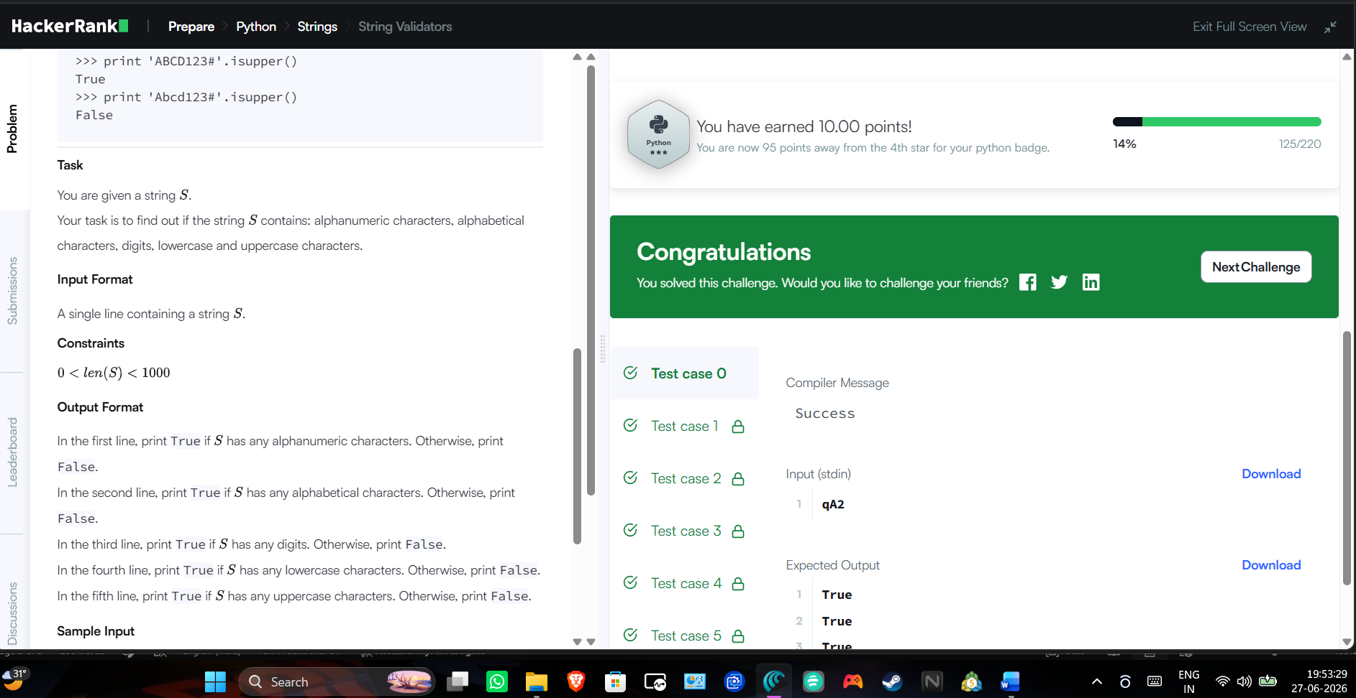

Task 2
You are given a string and your task is to swap cases. In other words, convert all lowercase letters to uppercase letters and vice versa.
For Example:
Www.HackerRank.com → wWW.hACKERrANK.COM
Pythonist 2 → pYTHONIST 2
Function Description
Complete the swap_case function in the editor below.
swap_case has the following parameters:
- string s: the string to modify
Returns
- string: the modified string
Input Format
A single line containing a string .
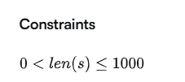
Sample Input 0
HackerRank.com presents "Pythonist 2".
Sample Output 0
hACKERrANK.COM PRESENTS "pYTHONIST 2".
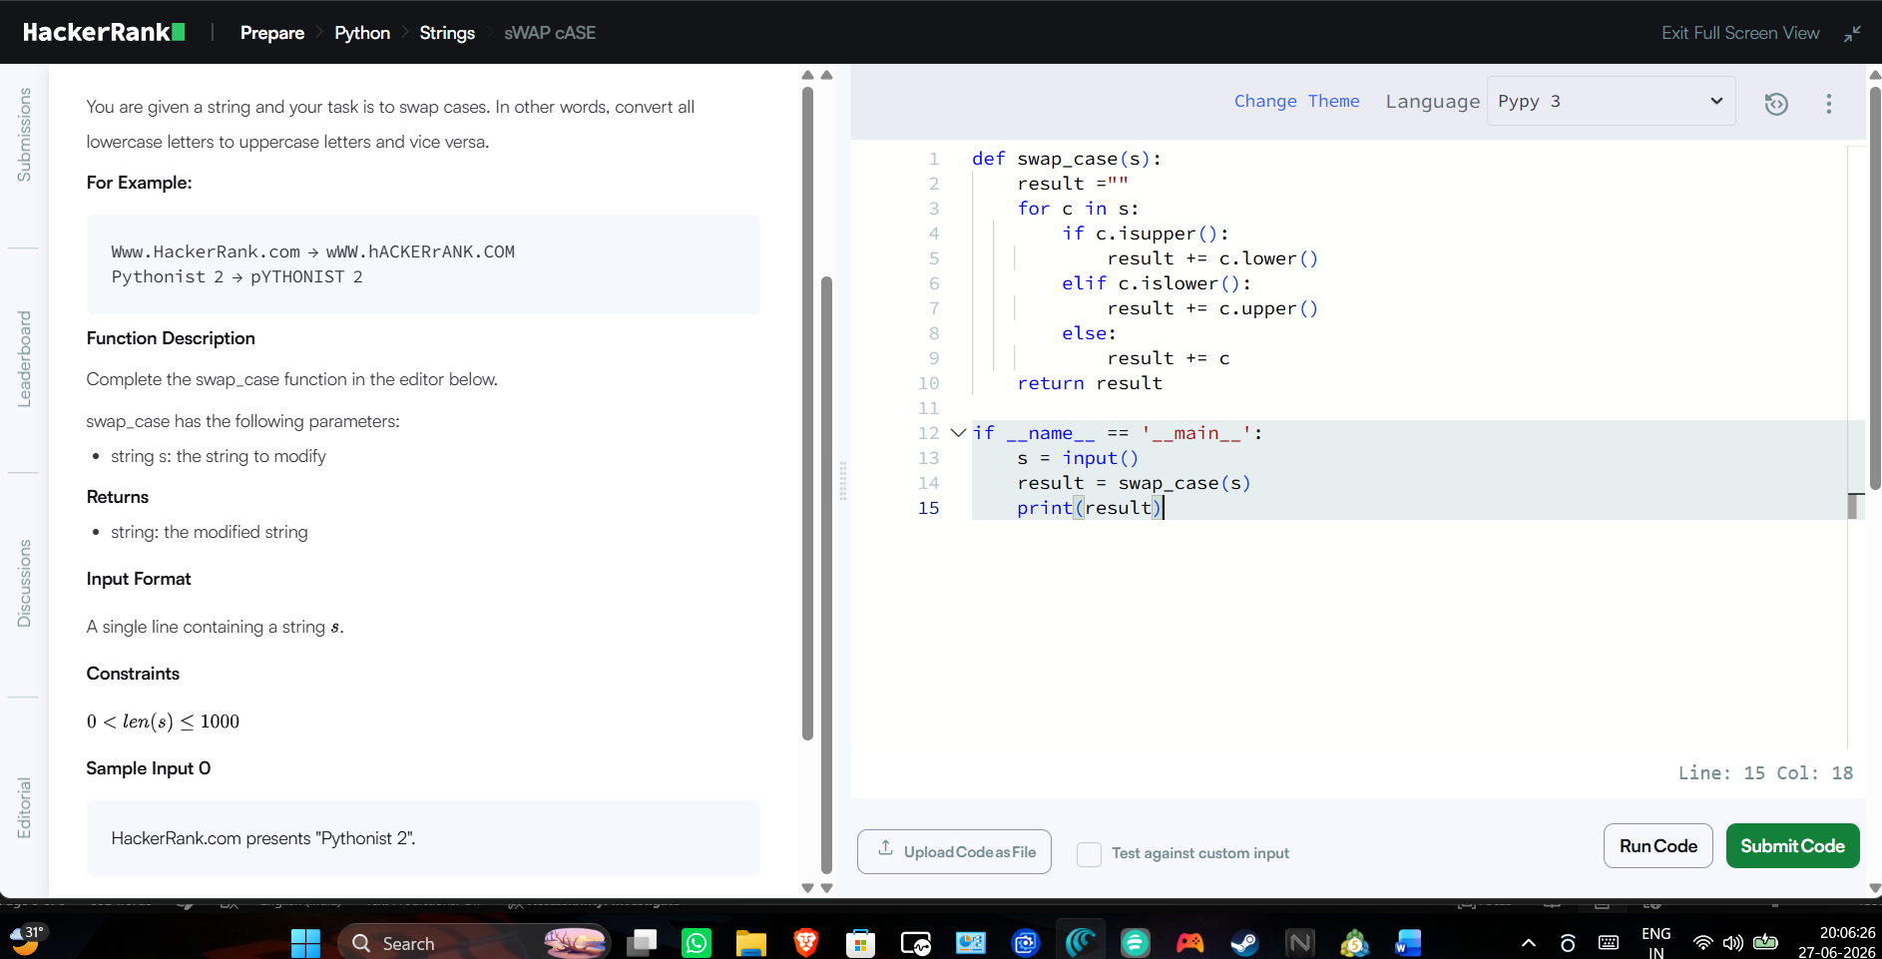
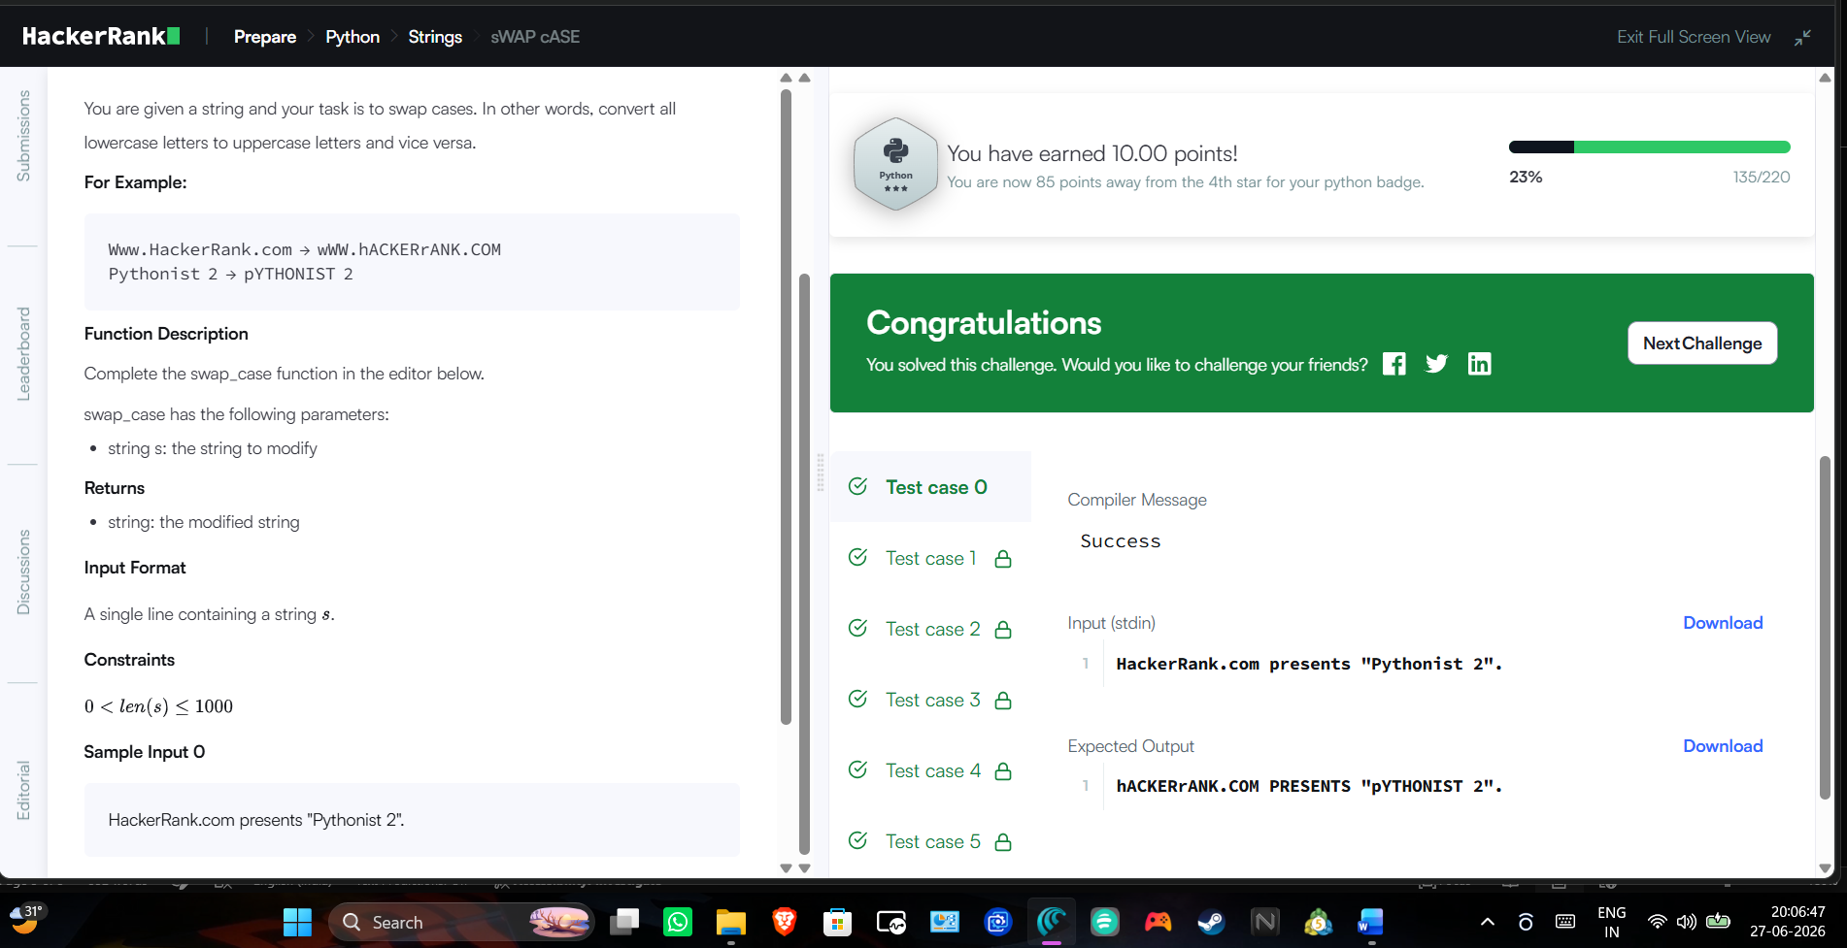

Task3
You are given a string. Split the string on a " " (space) delimiter and join using a - hyphen.
Function Description
Complete the split_and_join function in the editor below.
split_and_join has the following parameters:
- string line: a string of space-separated words
Returns
- string: the resulting string
Input Format
The one line contains a string consisting of space separated words.
Sample Input
this is a string
Sample Output
this-is-a-string
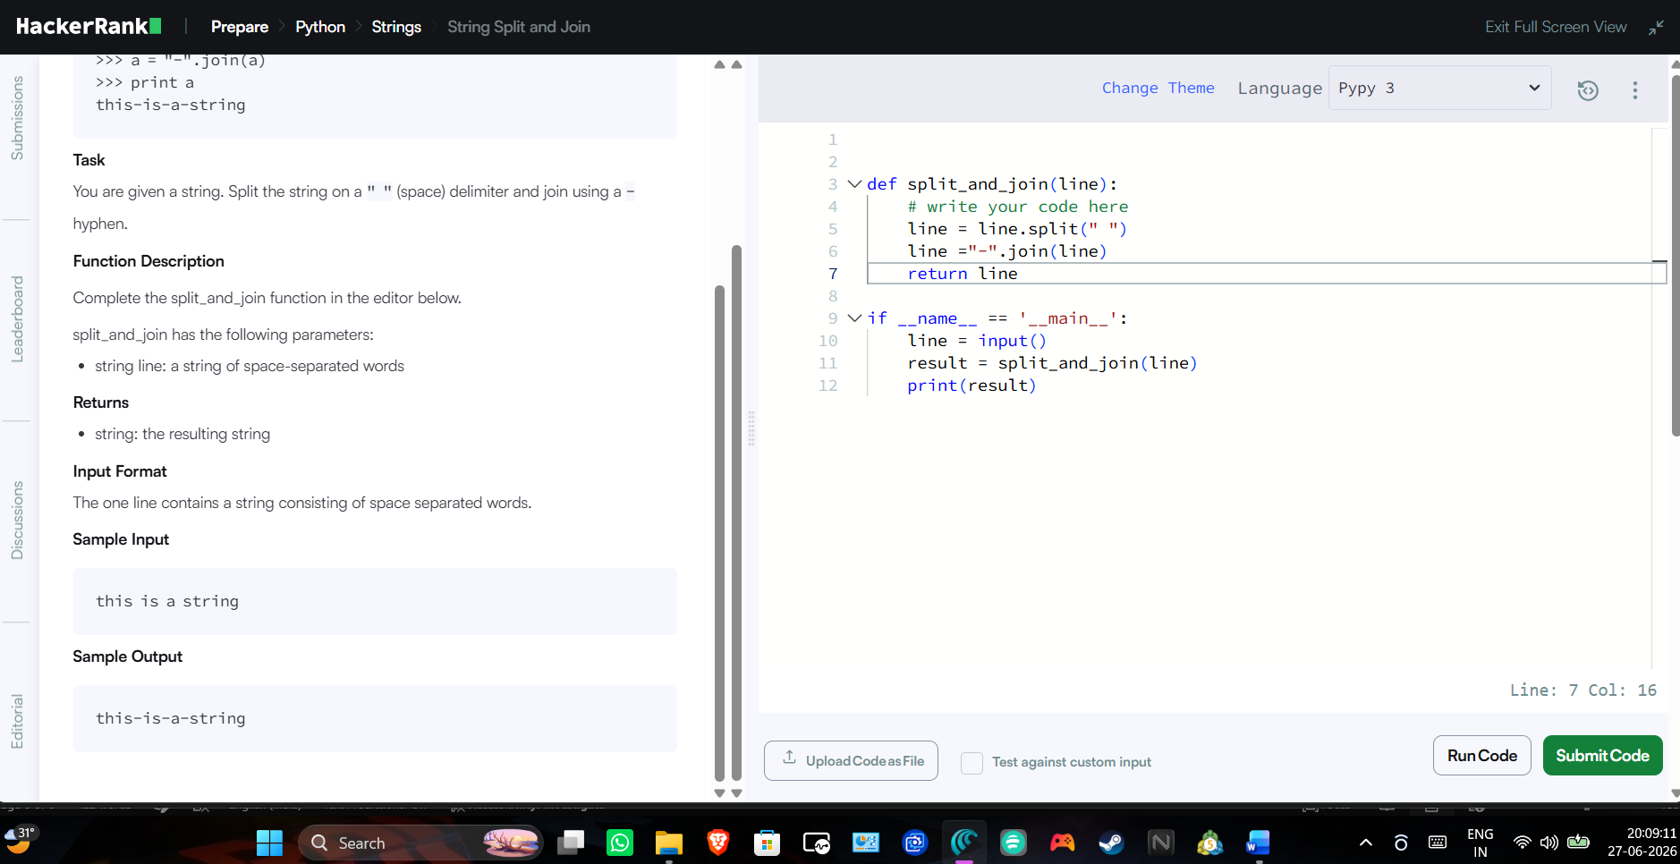
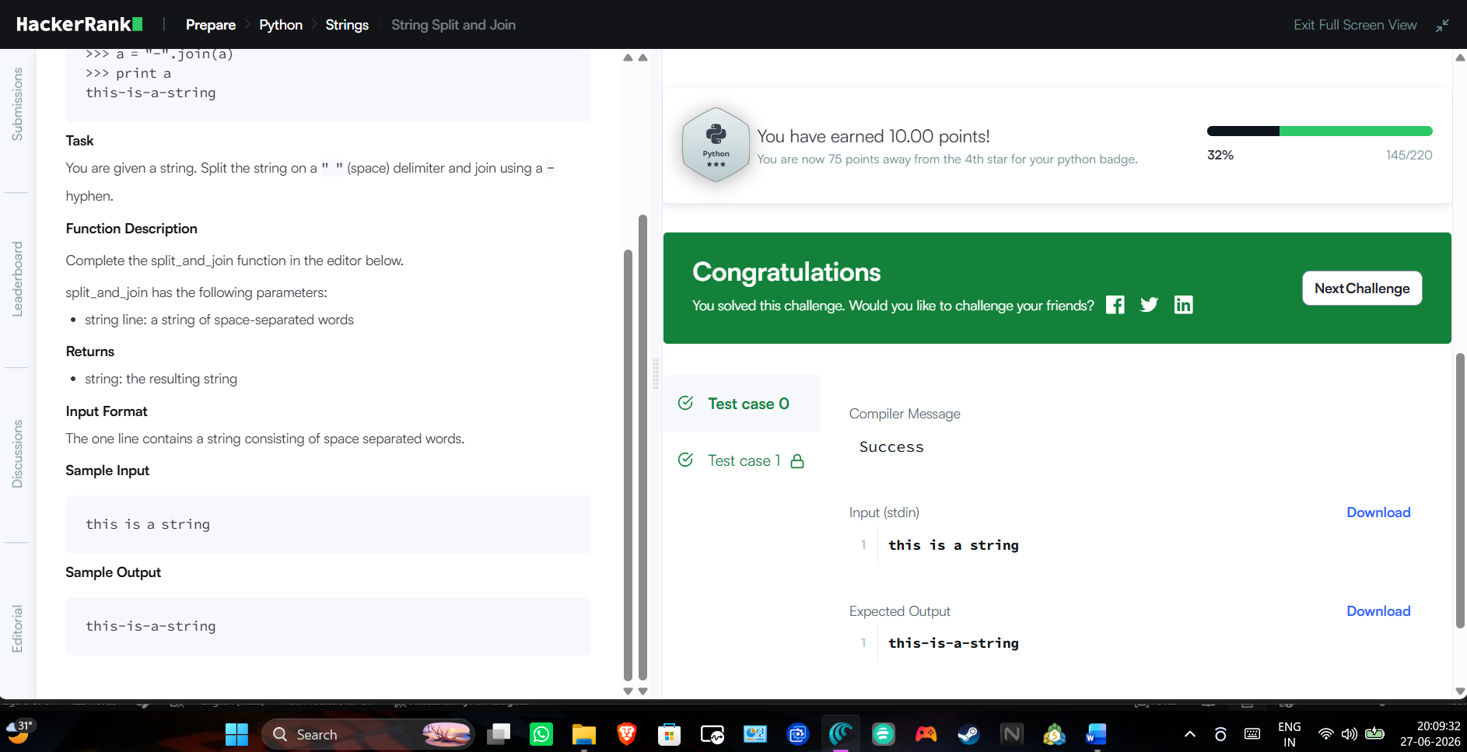

Task 4
Given an integer,n , print the following values for each integer 1 from n to :
- Decimal
- Octal
- Hexadecimal (capitalized)
- Binary
Function Description
Complete the print_formatted function in the editor below.
print_formatted has the following parameters:
- int number: the maximum value to print
Prints
The four values must be printed on a single line in the order specified above for each from to . Each value should be space-padded to match the width of the binary value of and the values should be separated by a single space.
Input Format
A single integer denoting .
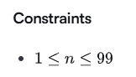
Sample Input
17
Sample Output
1 1 1 1
2 2 2 10
3 3 3 11
4 4 4 100
5 5 5 101
6 6 6 110
7 7 7 111
8 10 8 1000
9 11 9 1001
10 12 A 1010
11 13 B 1011
12 14 C 1100
13 15 D 1101
14 16 E 1110
15 17 F 1111
16 20 10 10000
17 21 11 10001
